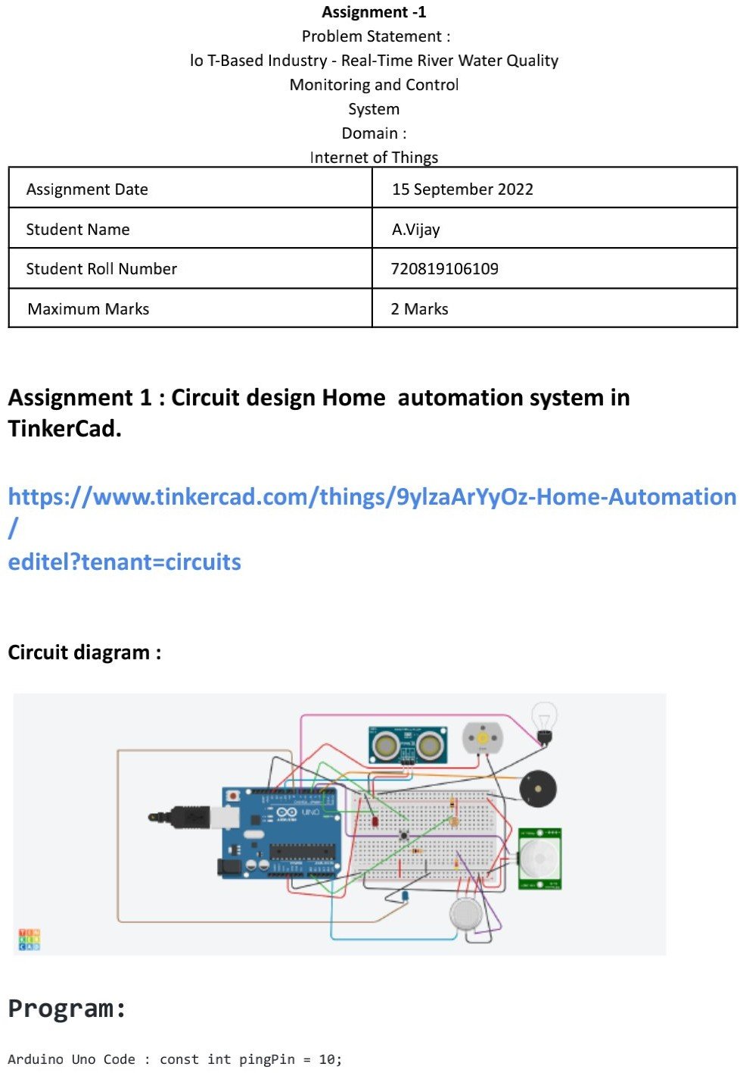

110719106021

N vijitha

3. Y Balaji -110719106039

4. N vijitha - 11071906

110719106018

110719106036

15 September 2022

2 Marks

V**.** MaheshBabu

